# COMP 353: Homework 2

## 2022-12-04

### Collaborators

* Anshul Narang
  + Setup the python file and loaded the airbnb sample dataset
  + Implemented all six queries based on the requirements
* Nick Shannon
  + Verified all six queries using CLI tools such as jq and grep
  + Prepared and Added screenshots of output

### MongoDB Queries

# Query 1 Results:  
# Select the top five largest numbers of listings; sort descending  
# (host_name, host_total_listings_count)  
query=listings.find({},{  
 "host.host_name": 1,  
 "host.host_total_listings_count": 1  
 }).sort("host.host_total_listings_count",-1).limit(5)  
  
for quer in query:  
 pprint.pprint(quer)

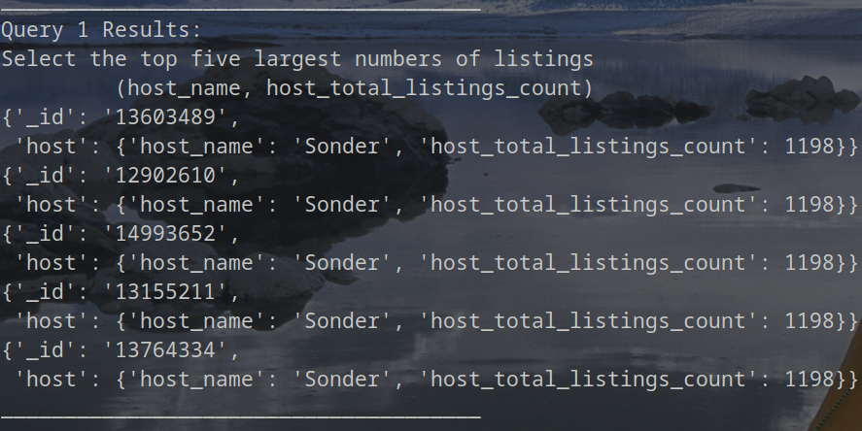

# Query 2 Results:  
# Select the top 10 listings with Cable TV, Wifi, and Iron amenities;   
# sort by minimum nights descending  
# (_id, minimum_nights, name, property_type)  
query=listings.find(  
 {  
 "$and": [  
 {"amenities" : "Cable TV" },  
 { "amenities" : "Wifi" },  
 { "amenities" : "Iron" }  
 ]  
 },  
 {  
 "_id": 1,  
 "minimum_nights": 1,  
 "name": 1,  
 "property_type": 1,  
 }).limit(10).sort("minimum_nights", -1)  
  
for quer in query:  
 pprint.pprint(quer)

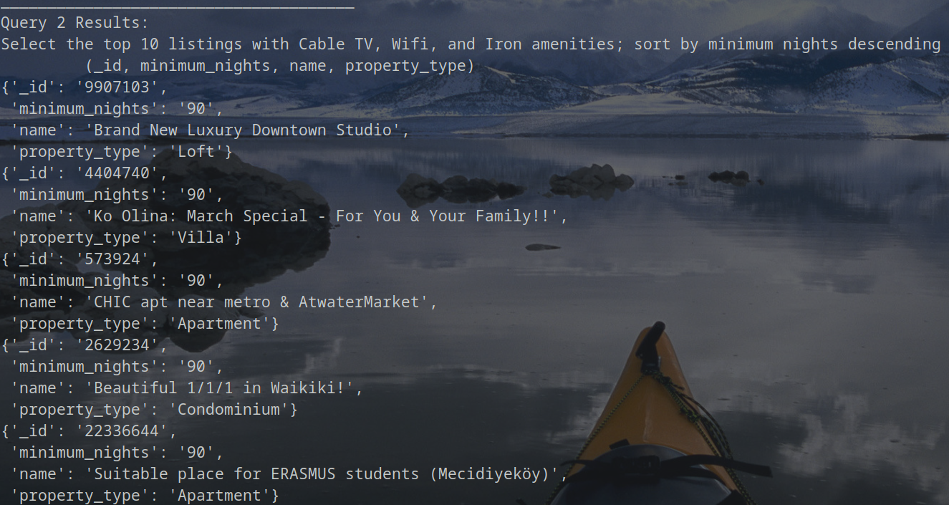 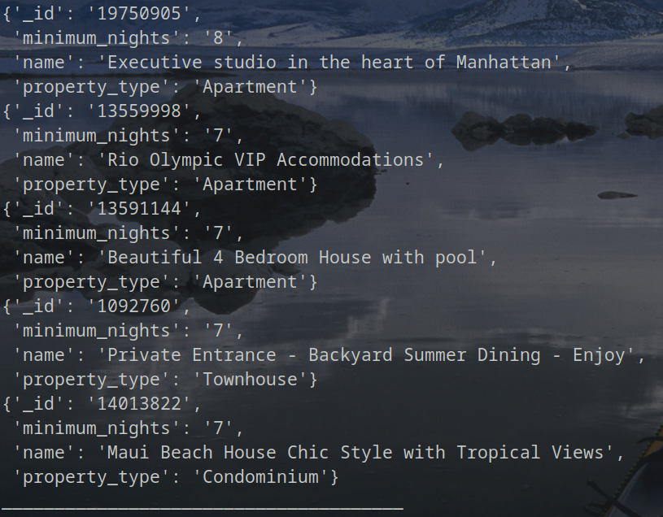

# Query 3 Results:   
# Select the maxium number of nights   
# (_id, name, property_type, maximum_nights)  
query=listings.find({},{  
 "_id": 1,  
 "name": 1,  
 "property_type": 1,  
 "maximum_nights": 1  
 }).limit(1).sort("maximum_nights",-1)  
  
for quer in query:  
 pprint.pprint(quer)

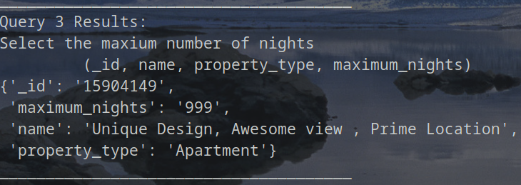

# Query 4 Results:   
# Select the five listings with between 5 and   
# 8 beds inclusive; sort descending   
# (_id, accomodates, bedrooms, beds, name, property_type)  
query=listings.find(  
 {   
 "$and":   
 [  
 {"accommodates" : {"$gte": 5,"$lte":8}},  
 {"beds": {"$gte" : 5}}  
 ]  
 },  
 {  
 "_id": 1,  
 "name": 1,  
 "property_type": 1,  
 "accommodates": 1,  
 "beds":1,  
 "bedrooms":1  
 }  
).sort("accommodates",-1).limit(5)  
  
for quer in query:  
 pprint.pprint(quer)

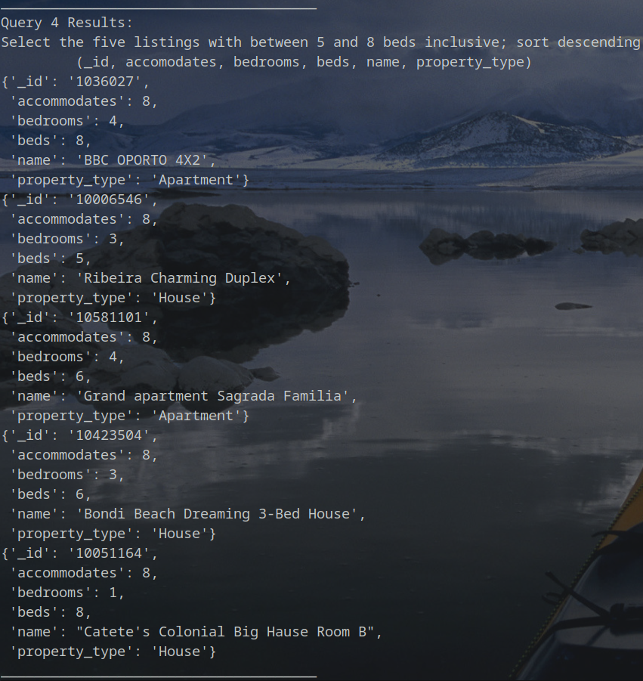

# Query 5 Results:   
# Select the top 5 listings where the number of bathrooms is greater than the number of bedrooms; sort descending by bathrooms   
# (_id, bathrooms, bedrooms, beds, name, property_type)  
query=listings.find(  
 {   
 "$expr":   
 { "$gt": [ "$bathrooms" , "$bedrooms" ] }   
 },  
 {  
 "_id": 1,  
 "name": 1,  
 "property_type": 1,  
 "bathrooms": 1,  
 "bedrooms":1,  
 "beds":1  
 }).sort("bathrooms",-1).limit(5)  
  
for quer in query:  
 pprint.pprint(quer)



# Query 6 Results:   
# Select the top 10 reviews; sort by review rating descending   
# (_id, name, property_type, review_scores.review_scores_rating, summary)  
query=listings.find({},{  
 "_id": 1,  
 "name": 1,  
 "property_type": 1,  
 "summary": 1,  
 "review_scores.review_scores_rating":1  
 }).sort("review_scores.review_scores_rating",-1).limit(10)  
  
for quer in query:  
 pprint.pprint(quer)

